**Overview**

Work individually to understand and establish the specifications for a PC dedicated to a specific task or application.

My PC application topic Is: Game computer

Answering the student questions will help you to develop a deeper understanding of the main components of a personal computer. It will also help you to identify the features that are most important for your specific PC application topic and the features that are nice to have but are not as critical for your topic.

Preparing a brochure explaining your PC application topic and your selection of personal computer components and features will help you to summarize what you have learned from the student questions. The brochure will also help you to share your findings in a “tradeshow” to be held in class.

The date for the “tradeshow” is: Wednesday, October 23rd, 2019

**Student Questions**

1. Think about your PC application topic. Do some research to find general answers to the following questions.
   1. How important is computer speed for my topic ( High / Medium / Low)? Justify your answer using examples of how a computer is used to perform a task related to your application.

* Computer speed is necessary for a game to run well
* Speed is necessary in a gaming computer as they need to work fast with a game
  1. How important is data storage for my topic ( High / Medium / Low)? Justify your answer using examples of how a computer is used to perform a task related to your application.
* Storage is important for a gaming computer as many games now take up large amounts of space
  + Around 1 to 2 TB should be good for a hard drive in a gaming pc
* Games can range from 10 gigabytes to 100 gigabytes
  1. How important is graphics and sound for my topic ( High / Medium / Low)? Justify your answer using examples of how a computer is used to perform a task related to your application.
* Sound and graphics are very important in gaming, especially for the modern games today
* Today’s games need good graphics in order to run games on their highest settings
  + While it may not be necessary for all games to run at high settings, to have the best gaming experience and to preform well, high graphics are recommended
* Sound is very crucial in gaming especially for games such as Call Of Duty and other first person shooters
  + These games need good sound as to help with the experience and to play well, surroundings would need to be heard
  1. How important is internet connectivity for my topic ( High / Medium / Low)? Justify your answer using examples of how a computer is used to perform a task related to your application.
* Online games require internet connectivity
* For the best gaming experience, it is best that there is high internet connectivity
* If the internet connectivity is not great, lag can occur during game play

1. CPU Processor Chip
   1. What speed of CPU Chip do you require? (High / Medium / Basic)

* High CPU speed is important in gaming as it helps with the overall experience and controls the instructions
* Medium would also suffice for gaming as well depending on the game
  1. Provide an example of a high speed CPU using the list of suppliers provided in the appendix. List the Model Number, Price, and Vendor Source. Also list its main features

Cost: $649.99 at newegg.ca

Specs:

* 3.60 GHz base speed and 5.0 GHz boost
* Intel UHD 630 integrated graphics
* 16mb cache

Overall performance:

* Overall very good for gaming and has high speeds
  1. Provide an example of a medium speed CPU using the list of suppliers provided in the appendix. List the Model Number, Price, and Vendor Source. Also list its main features

Cost: $199.99 at newegg.ca

Specs:

* 2.9 GHz base speed and 4.1 GHz boost
* 9mb cache
* Can run at 120 FPS and higher

Overall performance:

* Good for gaming but not great
* Will run games decently and will still run at high settings
* Can run at 100 FPS
  1. Provide an example of a basic speed CPU using the list of suppliers provided in the appendix. List the Model Number, Price, and Vendor Source. Also list its main features

Cost: $114.99 at newegg.ca

Specs:

* 3.5 GHz base speed and 3.7 GHz boost
* 6mb cache
* Radeon Vega 8 integrated graphics
* AMD Wraith Stealth Cooler

Overall performance:

* Not bad and can run games
* Can only be run at medium graphics but not well on high
* Around 60 FPS
  1. What would be the least expensive CPU Chip that meets your requirements? List the Model Number, Price, and Vendor Source.

Cost: $79.99 at newegg.ca

1. RAM Memory
   1. What size of RAM Memory do you require? (Large / Medium / Basic)

* Large ram size is required for games to run faster and to load quickly
  1. Provide an example of a large size RAM using the list of suppliers provided in the appendix. List the Model Number, Price, and Vendor Source. Also list its main features

Cost: $124.99 at newegg.ca

Specs:

* 16 GB of RAM
  1. Provide an example of a medium size RAM using the list of suppliers provided in the appendix. List the Model Number, Price, and Vendor Source. Also list its main features

Cost: $48.24 at newegg.ca

Specs:

* 8 GB of RAM
  1. Provide an example of a basic size RAM using the list of suppliers provided in the appendix. List the Model Number, Price, and Vendor Source. Also list its main features

Cost: $19.98 at newegg.ca

Specs:

* 4GB of RAM
  1. What would be the least expensive RAM Memory that meets your requirements? List the Model Number, Price, and Vendor Source.

Cost: $7.53 at newegg.ca

1. Graphics Card
   1. What graphics speed and resolution do you require? (High / Medium /Basic - On Motherboard)

* Graphics cards are important for different games resolution to make the experience much better
  1. Provide an example of a high-end Graphics Card using the list of suppliers provided in the appendix. List the Model Number, Price, and Vendor Source. Also list its main features

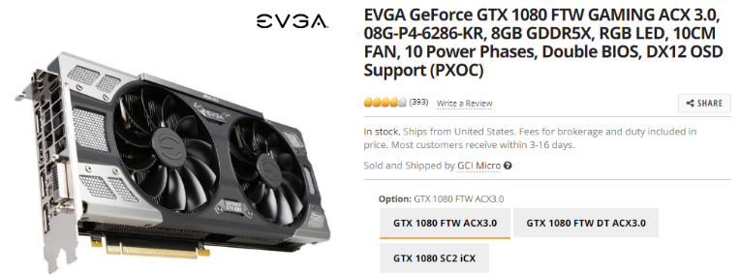

Cost: $1,199 at newegg.ca

Specs:

* 8GB 256-Bit GDDR5X
* Core Clock 1721 MHz
* Boost Clock 1860 MHz
  1. Provide an example of a medium-end Graphics Card using the list of suppliers provided in the appendix. List the Model Number, Price, and Vendor Source. Also list its main features

Cost: $549 at newegg.ca

Specs:

* 6GB 192-Bit GDDR5
* Core Clock 1506 MHz
* Boost Clock 1708 MHz
  1. What would be the least expensive Graphics Card that meets your requirements (or do you just need basic graphics provided by the motherboard)? List the Model Number, Price, and Vendor Source.

On-Board graphics

1. Sound Card
   1. Do you require special sound support? (High / Medium /Basic - On Motherboard)
   2. Provide an example of a high-end Sound Card using the list of suppliers provided in the appendix. List the Model Number, Price, and Vendor Source. Also list its main features

Cost: $114.99 at newegg.ca

Overall performance: Good audio and is 3d.

Provide an example of a medium-end Sound Card using the list of suppliers provided in the appendix. List the Model Number, Price, and Vendor Source. Also list its main features

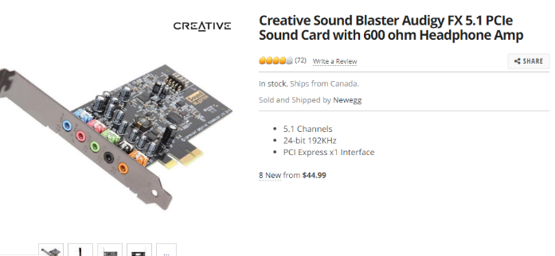

Cost: $44.99 at newegg.ca

Overall performance: Also good audio and not much of a difference.

* 1. What would be the least expensive Sound Card that meets your requirements (or do you just need basic sound provided by the motherboard)? List the Model Number, Price, and Vendor Source.

On-Board sound

1. Motherboard
   1. Do you require any special motherboard features (based on your answers to the above questions)?

No

* 1. Provide an example of a high-end Motherboard using the list of suppliers provided in the appendix. List the Model Number, Price, and Vendor Source. Also list its main features

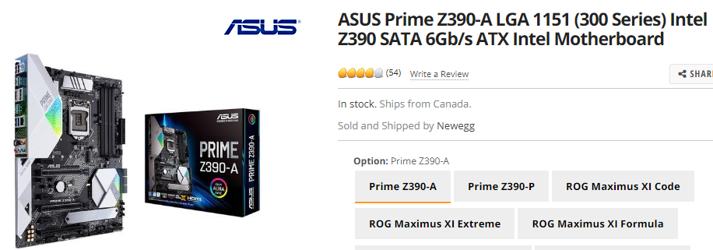

Cost: $239.99 at newegg.ca

* 1. Provide an example of a basic Motherboard using the list of suppliers provided in the appendix. List the Model Number, Price, and Vendor Source. Also list its main features

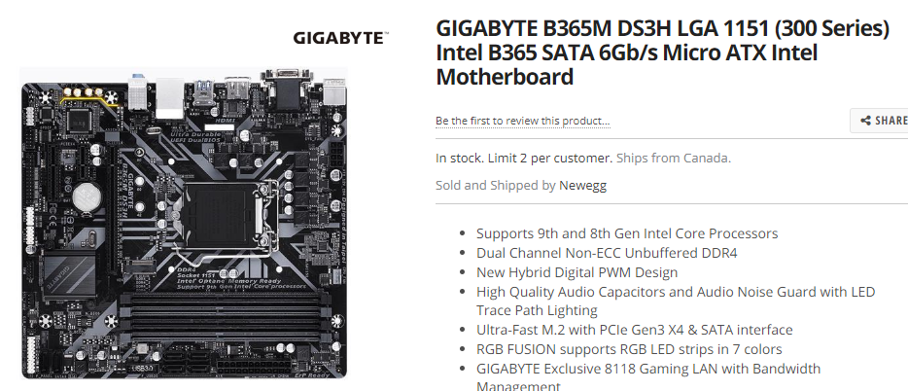

Cost: $104.99 at newegg.ca

* 1. What would be the least expensive Motherboard that meets your requirements? List the Model Number, Price, and Vendor Source.

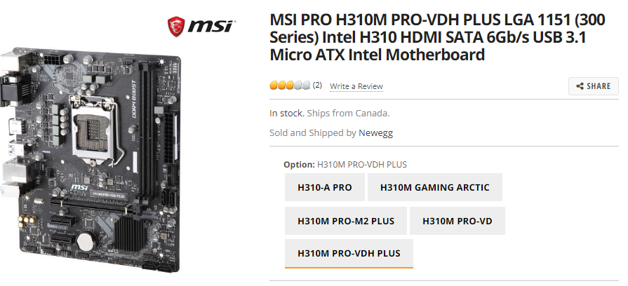

Cost: $84.99 at newegg.ca

1. HDD (Hard Disk Drive or Solid State Drive)
   1. Do you require any special Hard Disk Drive features (based on your answers to the above questions)?

No

* 1. Provide an example of a high-end HDD using the list of suppliers provided in the appendix. List the Model Number, Price, and Vendor Source. Also list its main features

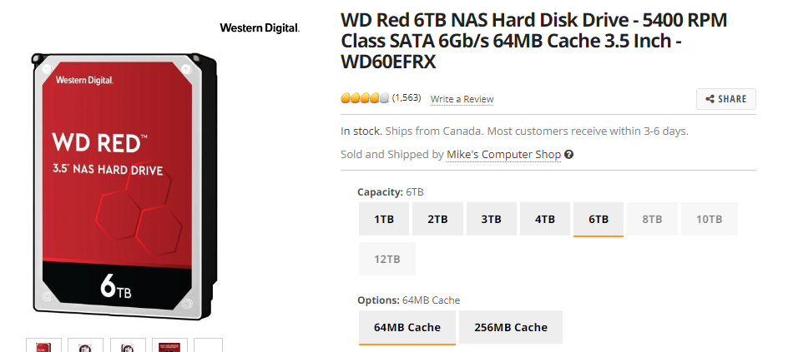

Cost: $290.59 at newegg.ca

6TB of storage

* 1. Provide an example of a basic HDD using the list of suppliers provided in the appendix. List the Model Number, Price, and Vendor Source. Also list its main features

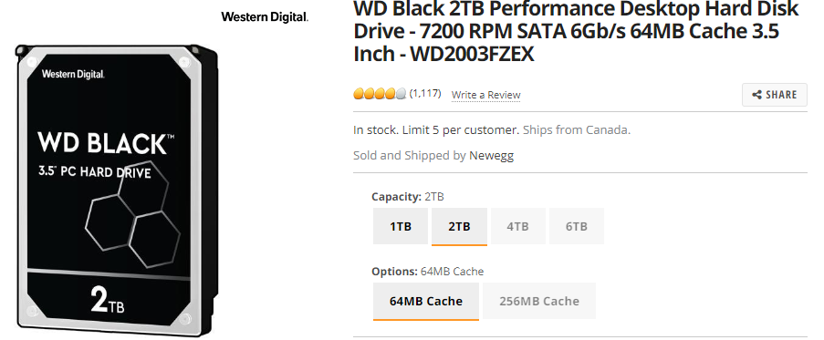

Cost: $154.99 at newegg.ca

2TB of storage

* 1. What would be the least expensive Hard Disk Drive that meets your requirements? List the Model Number, Price, and Vendor Source.

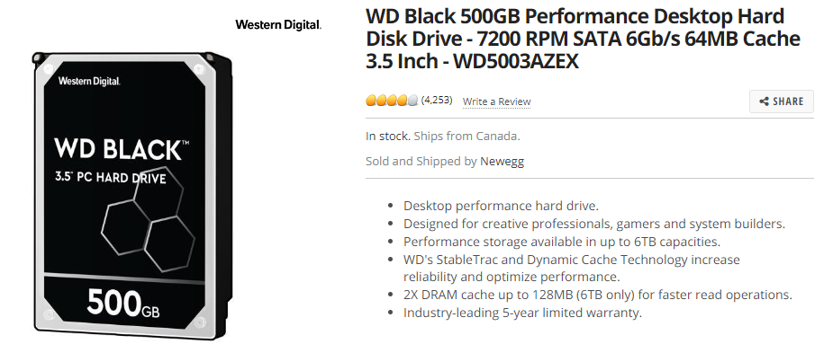

Cost: $79.99 at newegg.ca

500GB of storage

1. Removable Media (DVD / USB / Flash)
   1. Do you require any special Removable Media features? Explain what extra features are required for your PC application topic.

N/A as I personally use Gmail and cloud based storage eliminating the use of removable media.

* 1. If so, List the Model Number, Price, and Vendor Source for any of these extra features.

1. Network Interface (Ethernet /Fiber / Wi-Fi / Bluetooth)
   1. Do you require any special Network Interface features? Explain what extra features are required for your PC application topic.

Ethernet may be more beneficial for gaming as there would be less lag and the connection would be better for ping.

* 1. If so, List the Model Number, Price, and Vendor Source for any of these extra features.

Ethernet cable

1. Monitor, Mouse, Keyboard
   1. Do you require any special Monitor, Mouse, Keyboard, etc. add-ons? Explain what extra features are required for your PC application topic.

I do not necessarily need special features as I use normal keyboards, mice, and a monitor which is not a gaming monitor.

* 1. If so, List the Model Number, Price, and Vendor Source for any of these extra features.

1. Portability / Mobility
   1. Will you be using your PC in one place, do you need some portability, or do you need a high degree of mobility? Explain the need for portability your PC application topic.

I do not require much mobility for a gaming computer as I would most likely only use it at home. I would not do much gaming on a laptop outside my house unless it was for a long period of time which I doubt so I would be ok with not much portability.

* 1. Do you require a Desktop / Laptop / Notebook or other PC format?
  2. How will this affect the cost of your dream machine.

It will be cheaper as I will not have to pay as much for the mobility as a gaming laptop would be more expensive as it must all be compact into a laptop which makes it cost more.

1. Rank each personal computer component in order of priority (1-lowest, 10-highest) based on your research above. Each component must have its own priority number… no duplications.
   * CPU Processor Chip 1 2 3 4 5 6 7 8 9 10
   * RAM Memory 1 2 3 4 5 6 7 8 9 10
   * Graphics Card 1 2 3 4 5 6 7 8 9 10
   * Sound Card 1 2 3 4 5 6 7 8 9 10
   * Motherboard 1 2 3 4 5 6 7 8 9 10
   * HDD (Hard Disk Drive or Solid State Drive) 1 2 3 4 5 6 7 8 9 10
   * Removable Media (DVD / USB / Flash) 1 2 3 4 5 6 7 8 9 10
   * Network Interface (Ethernet /Fiber / Wi-Fi / Bluetooth) 1 2 3 4 5 6 7 8 9 10
   * Monitor, Mouse, Keyboard 1 2 3 4 5 6 7 8 9 10
   * Portability / Mobility 1 2 3 4 5 6 7 8 9 10

**Brochure**

Work individually to create a 4 page brochure according to the following guideline.

**Page 1 – Your Application Topic**

Describe your topic and the top PC components for your topic.

Include the following on this page:

* Describe your application topic and how a PC is used
* In general terms, describe what the best PC for this application would look like (e.g. speed vs portability)
* Describe in more detail the top three most important PC components and explain why they are important for your application

**Page 2 – Would-Be-Nice Features**

Describe your decisions about what PC components are less important but would be nice to upgrade if you had the money.

Include the following on this page:

* Describe the would-be-nice components (just below your top 3 priorities) and what your options for upgrading them would be.
* Describe the components / features at the bottom of your priority list and why you would not spend extra money on them.
* Provide some details about different vendors / suppliers and the options they offer.

**Page 3 – Your Budget Machine**

Your budget is $800. Select a pre-packaged PC or customize / build a PC from parts to fit under this budget.

Include the following on this page:

* Your PC specs, model, cost, vendor, etc.
* Priority components that you were able to include for this price.
* Priority components that you had to leave out because of budget limitations.

**Page 4 – Your Dream Machine**

Your budget is $2000. Select a pre-packaged PC or customize / build a PC from parts to fit under this budget.

Include the following on this page:

* Your PC specs, model, cost, vendor, etc.
* Priority components that you were able to include for this price.
* Priority components that you were able to spend extra on.
* Also comment on any priority components that you had to leave out or down-grade.

**Appendix A: PC Vendors, Parts, & Customization**

Suggested on-line computer sources:

* [www.newegg.ca](http://www.newegg.ca)
* [www.dell.com/en-ca](http://www.dell.com/en-ca)
* [www.tigerdirect.ca/](http://www.tigerdirect.ca/)
* [www.canadacomputers.com](http://www.canadacomputers.com)

**Appendix B: Application Topics**

|  |  |
| --- | --- |
| **Task** | **Student Name** |
| ***Game Computer*** |  |
| **Photo Editing & Organization** |  |
| ***Business Office Computer*** |  |
| ***Student Home Computer*** |  |
| ***Factory Floor Computer*** |  |
| ***Media Production and Streaming Computer*** |  |
| ***Web Surfing Computer*** |  |
| ***Game Computer*** |  |
| **Photo Editing & Organization** |  |
| ***Business Office Computer*** |  |
| ***Student Home Computer*** |  |
| ***Factory Floor Computer*** |  |
| ***Media Production and Streaming Computer*** |  |
| ***Web Surfing Computer*** |  |
| ***Game Computer*** |  |
| **Photo Editing & Organization** |  |
| ***Business Office Computer*** |  |
| ***Student Home Computer*** |  |
| ***Factory Floor Computer*** |  |
| ***Media Production and Streaming Computer*** |  |
| ***Web Surfing Computer*** |  |